**In-Game Element Modification Techniques**

How other games do it

Big Pharma

In big pharma, there are four types of machines that perform element modification: Basic, Advanced, Auxiliary and Makers. I will briefly go over each of these types of machine and how they affect gameplay.

Basic machines take an input and modify concentration of that input. There are some that increase/decrease the concentration by 1 (‘Evaporators’ and ‘Dissolvers’), some that increase/decrease it by 3 (‘Agglomerators’ and ‘Ionisers’) and others that double/halve the concentration of an input (‘Autoclaves’ and ‘Cryogenic Condensers’). These are all relatively simple mechanics that act in a single property of an input, concentration.

It is worth noting that different machines have different ‘Process Costs’ and different ‘Process Time’ (Game ticks to complete the modification) so in the case of Big Pharma it is slightly more efficient cost-wise to have 3 Evaporators instead of 1 Agglomerator, but this would take up more space on the factory floor.

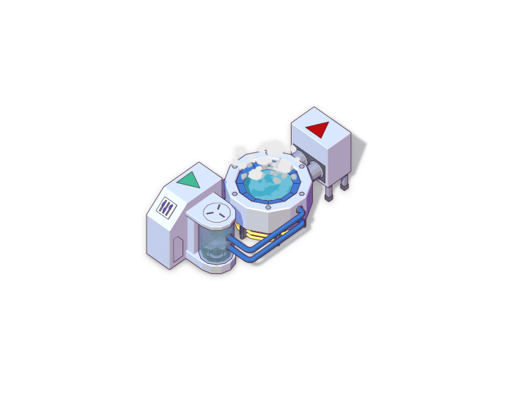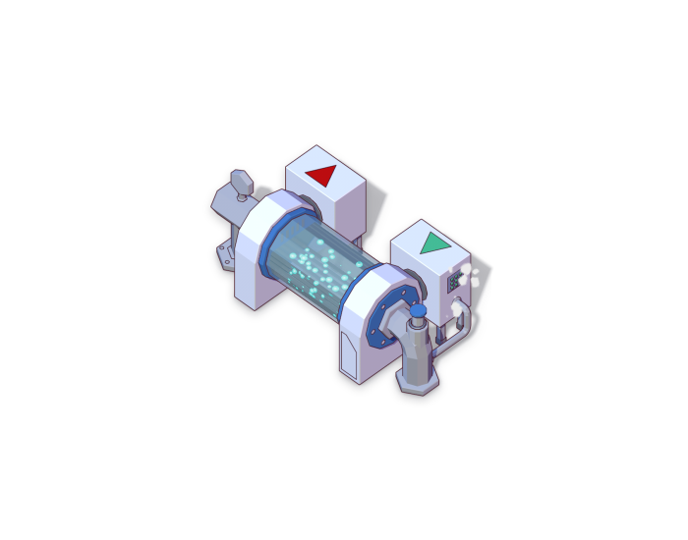

Figure 1 Dissolver Figure 2 Evaporator

Advanced Machines still affect concentration but usually in more drastic ways than basic machines. The first advanced machine, the ‘Ultraviolet Curer’ sets an inputs concentration level to 1. There is the ‘Sequencer’ which lets you select which concentration value you want the input to go to, from a set list of values (2, 10 and 18 in Big Pharma). The ‘Chromatograph’ takes an input and based on its current concentration level, either reduces or increases the concentration level by 10. Lastly there is the ‘Hadron Collider’ which is particularly strange. It sets the concentration of the input to all values possible. This has the effect of enabling all the effects and side-effects of the drug simultaneously, regardless of their concentration requirement.

In general, advanced machines cost a lot more and take a lot longer to operate than basic machines.

Auxiliary machines are different to the other machines covered since their purpose is not to affect concentration directly and therefore will require a bit more explanation compared to the previous machines.

First there is the ‘Analyser’ which takes an input, finds out which concentration level the effects and side effects of the ingredient are most potent (called the maximum strength concentration of a drug trait) and then destroys the input. The analyser has a success rate based on how often the input is given to the analyser. The more inputs fed to it over a set amount of time, the higher the success rate of finding the maximum strength concentration

of drug traits.

There is the ‘Multimixer’ which combines two ingredients traits together. This can be useful to gain positive effects for the drug being produces or to gain catalysts for that drug. The diagram below shows exactly how it works:

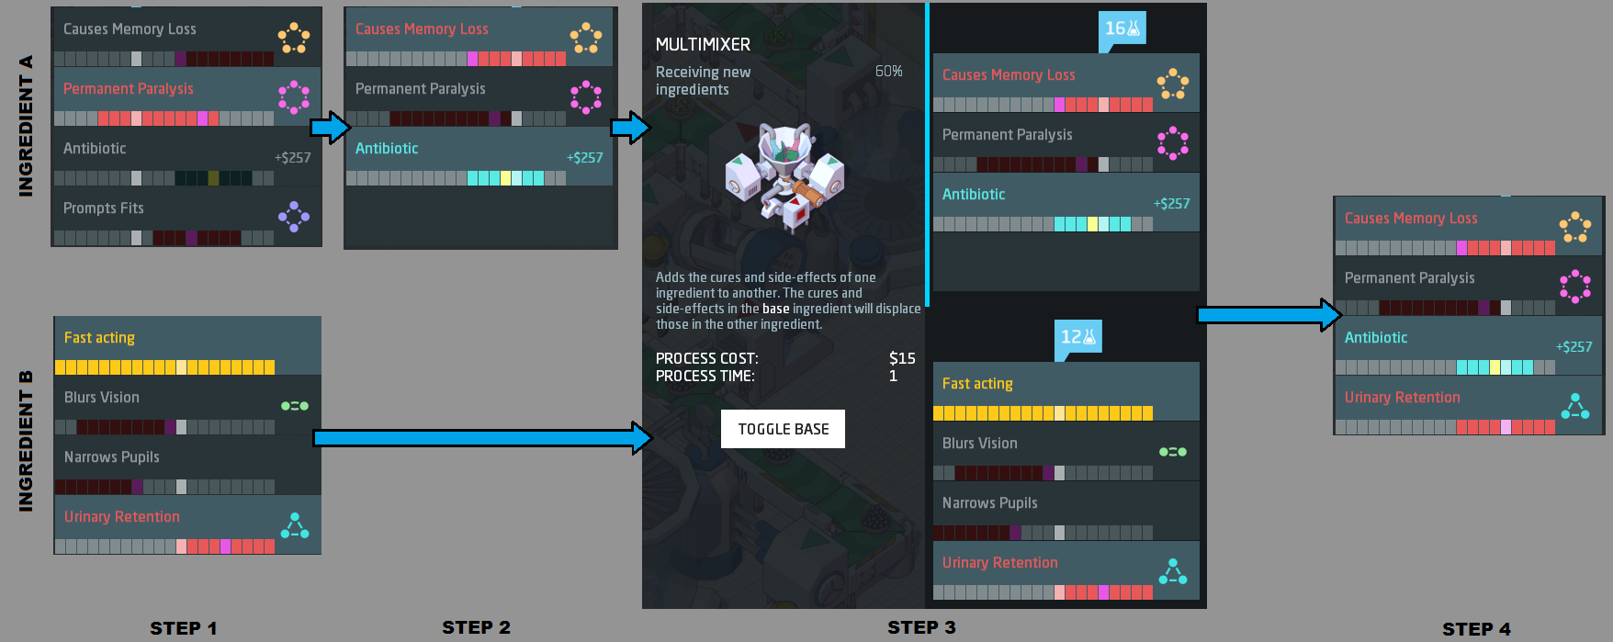

There is a ‘Shaker’ which switches the order of the drug traits, useful in combination with a ‘Multimixer’ to pass a trait on to a base ingredient.

There are a few auxiliary machines but I won’t go in to detail on them all since that isn’t the point of this research.

The final type of machine is a ‘Maker’ machine. These are used to package the drug up in a form that can be used by the consumer.

Firstly, there is the Pill Printer, with a process of time of 2 and taking up a relatively small amount of space compared to other maker machines, it is a good choice early on.

There is the ‘Creamer’ which has the benefits of reducing side effects by 50-75% and having a process time of 1, however it is expensive to run.

There is a ‘Sachet Fabricator’ which packages your drug in a sachet, it is nearly the same as the pill printer except for the fact that it’s slightly larger but adds more value to the finished product.

Finally, there is the ‘Syringe Injector’ which packages drugs in to a syringe form, increasing strength of the drug and value. It is the creamers counterpart.

As you can see, Big Pharma has a lot of detail in the machines used to modify drugs as this is the core mechanic the game relies on, so they fleshed it out a lot. They game also has research built in to it which lets your upgrade the machines over time, reducing process costs of the machines and providing other benefits.

Infinifactory

I don’t own Infinifactory so this research will entirely be based on the first few levels of gameplay and sources found on the internet.

**Welders**

Welders in [Infinifactory](https://infinifactory.gamepedia.com/Infinifactory_Wiki) are blocks that can "weld" multiple component blocks together. e.g. if two blocks are going down conveyors side-by-side, a welder on each side pointing inward will weld those two 1x1x1 blocks into a single 2x1x1 multiblock.

All blocks that enter the welding lasers at the same time are welded together. If one or more of the blocks within the lasers are part of multiblock(s), the multiblock(s) are welded together. It is *not* necessary for the entire multiblock to be within the welding lasers.

Welders are 1x1x1 blocks, that come in a rotatable, horizontal, version; and a non-rotatable, downward facing version. The two versions *are* compatible with each other, so you can weld blocks into "L" shapes, or on top of each other and so forth. To link a downward welder with a horizontal welder, simply place the downward facing welder with two empty blocks under it (anchoring the welder from the side, or above), and place a horizontal welder pointing at the lower of the two empty blocks.

**Eviscerators**

The Eviscerator is a placeable 2x1x1 multiblock that is used to destroy other blocks. It consists of a single base block and a drill. The eviscerator must be positioned and rotated by the base block. By rotating the base block, the drill can be made to point in all four directions, but cannot point up or down.

**Lifters**

The Lifter is a 1x1x1 block which resembles a fan. Any block(s) passing over the lifter will be raised up until a certain fixed amount of vertical space exists between the lifter and the blocks. This means that if extra blocks arrive at the lifter while it is already lifting some blocks, the new block will be lifted and push the existing lifted blocks upwards.

**Rotators**

The Rotator is a 1x1x1 block which rotates other blocks. There are two versions of the rotator, which rotate clockwise and anticlockwise respectively. Any block placed on the rotator is rotated by 90 degrees. The rotator then stops, acting as a [Platform](https://infinifactory.gamepedia.com/Platform) until a new block is placed on it, usually as a result of the block currently on it being pushed off by a [Pusher](https://infinifactory.gamepedia.com/Pusher) or another incoming block.

**Pusher**

The Pusher is a 1x1x1 logic block which is used to control the movement of other blocks.

The pusher does nothing unless it is activated by a conduit from a sensor. When activated, the pusher's active face extends, making the pusher become 2x1x1. Any block in the block-space immediately in front of the pusher will be pushed away from it. The pusher's extended active face can then block the movement of other blocks. When attached sensors deactivate, the pusher's active face will retract. It is the reverse of the [Blocker](https://infinifactory.gamepedia.com/Blocker)

**Blocker**

The Blocker is a 1x1x1 block which behaves as the exact reverse of the [Pusher](https://infinifactory.gamepedia.com/Pusher). It extends when not activated, and retracts when activated.

How we could do it in our game

The biggest difference between both the games I researched is that one is focused on the assembly of a structure and the other is focussed on changing the stats of a drug.

I believe there is room to do something more unique here and add more interesting mechanics with equal simplicity (not implying that the Big Pharma modifier tools are simple). Although it’s hard to come up with an idea right here I think it’s worth looking more in to this.

If we were to go with a cooking theme, we could have machines or workstations that heat up food that passes through, that cook food, chop up ingredients, mix ingredients, cool down food, freeze it, deep-fry etc. There are a lot of routes to explore with cooking different types of food. It would be nice to be able to manipulate the way the food looks and affect stats at the same time. For example, the heater would increase the heat property of the food that passes through it but may also glaze the food on top if left in too long or burn it.

I also think we could tune the machines more. Instead of having machines that do a set function the same every time, it would be nice to be able to tune how powerful they are, which could scale with energy being used. I think this would add a nice layer of customisation to the player experience.